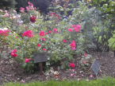
Burial of ashes in St Martin’s is in the Rose Garden, and a bush rose may be planted on the plot. Other plants are not permitted. Ashes may also be buried in an existing
grave space. It is possible to bury more than one set of cremated remains in a plot as long as this is indicated prior to the first burial and sufficient space therefore allowed.
Benches and other items
We have been fortunate to have had a
number of benches donated to our churchyards. These provide valuable places for reflection and prayer. No further benches are now needed. However, items are always needed for inside the church, and the Rector would be happy to discuss items that might be given (and marked) “in memoriam”.
Support for the bereaved
Many of our church members have themselves suffered the loss of loved ones and are very aware of the pain this causes. We want to be as supportive as possible of those suffering bereavement. A Pastoral Care team is available to visit those who would like to talk through their loss. Occasional services are held to remember the Departed and to pray for those who mourn. Each November, at All Souls, we remember all those who have departed in the previous year.
Remembering
Both St Martin’s and St Peter & St Paul have memorial books. Any parishioner may place the name of a loved one in the book by applying to the parish office. Some families like to mark the anniversary of the passing of a loved one by arranging the flowers in church that week, or by making a donation towards the cost of a flower arrangement. More details are available from the parish office. There is a good record of all the known graves in St Martin’s churchyard and information can be supplied by the parish office.

St Martin, Eynsford
St Peter and St Paul, Farningham
St Botolph, Lullingstone
Churchyard Policy 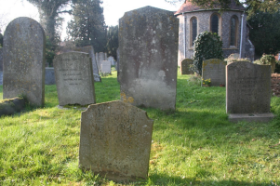
EFL Benefice Office,
St Martin’s Church,
4 Church Walk, Eynsford, Kent DA4 0EH
01322 863050
efloffice3@gmail.com

Rector: Vacancy
www.efl-churches.org

Introduction
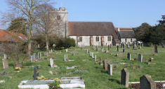
From the earliest times, a churchyard has been regarded as “God’s acre” and as far as possible it should suggest something of the nature of a garden. Everything in a churchyard, from the memorial stones to the trees and shrubs should be a matter for care and consideration. It is with this in mind that the Diocese of Rochester has set out guidelines for the care and upkeep of churchyards, so that they may remain neat and tidy throughout the year. Churchyards are places of peace, and this should be respected.
Burials
St Martin's Churchyard in Eynsford is closed to new burials.
However, burials in existing family graves may still take place. St Peter & St Paul's in Farningham and St Botolph's in Lullingstone are open with limited spaces. Therefore, only residents of each parish, or members of the church electoral roll have an automatic right to burial. Burials will also normally be agreed for anyone who has lived in the parish for a significant period (over 10 years or 25% of their life), or for people who were resident in the parish prior to entering residential care. The Rector’s decision in such cases is final. There is no right to choose a particular plot for burial. It may be possible in exceptional circumstances to reserve a grave plot by faculty application to the Chancellor of the Diocese.

Memorials
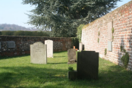
There is no automatic right in English law to erect any monument, and indeed few graves were marked prior to the nineteenth century. Permission must be sought from the Rector for any memorial or headstone prior to its erection. This can be done via a Funeral Director or Monumental Mason, using a CR1 form. Provided the proposed monument meets certain criteria, the Rector is free to grant permission.

Any monument falling outside Diocesan guidelines requires the family to apply for a faculty from the Chancellor of the Diocese.
Please note that the following is not permitted:
• The use of marble, dark granite, polished or painted stone
• The use of kerbs or chippings
• Photographic or etched images, and statues
• Inscriptions which address the person who has died
Headstones may incorporate a vase into which natural flowers can be placed.

Memorials remain the responsibility of those who erect them. However, if a memorial becomes unsafe the Church reserves the right to lay memorials flat to prevent injury to third persons.
Care of graves
The Churches endeavour to maintain their churchyards in a tidy and presentable manner. However, some areas may be left to grow wild, to encourage biodiversity.
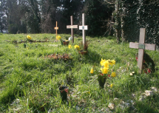
The best way to care for a grave is to grass it over. Then it is easy to maintain and will be cut by the church yard maintenance team.
Families are welcome to place natural flowers on a grave, but plastic flowers are not permitted, neither are toys, statues, candles, pots or vases. Bulbs or small annuals may be planted.
Cremated remains
Each churchyard has space set aside for the burial of cremated remains and these spaces are allocated on a similar basis to grave spaces. Ashes must be poured into the allocated space and not buried in a casket or scattered. Once buried, ashes cannot be removed and reburied elsewhere.
All three churches permit a plaque to be placed at the site of burial, subject to form CR1 approval from the Rector.

