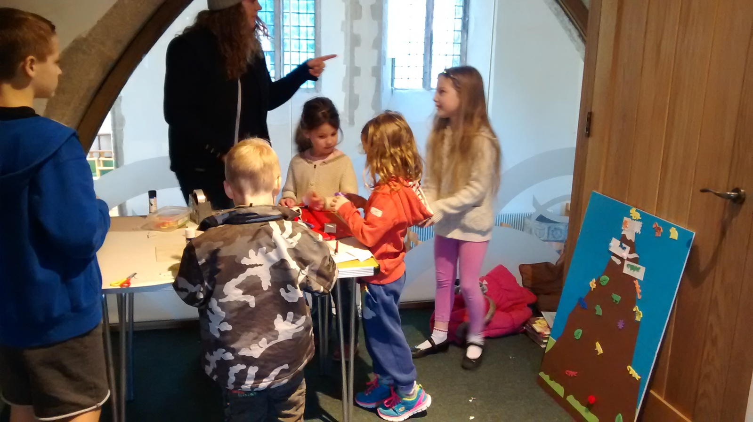
'Making' our base camps

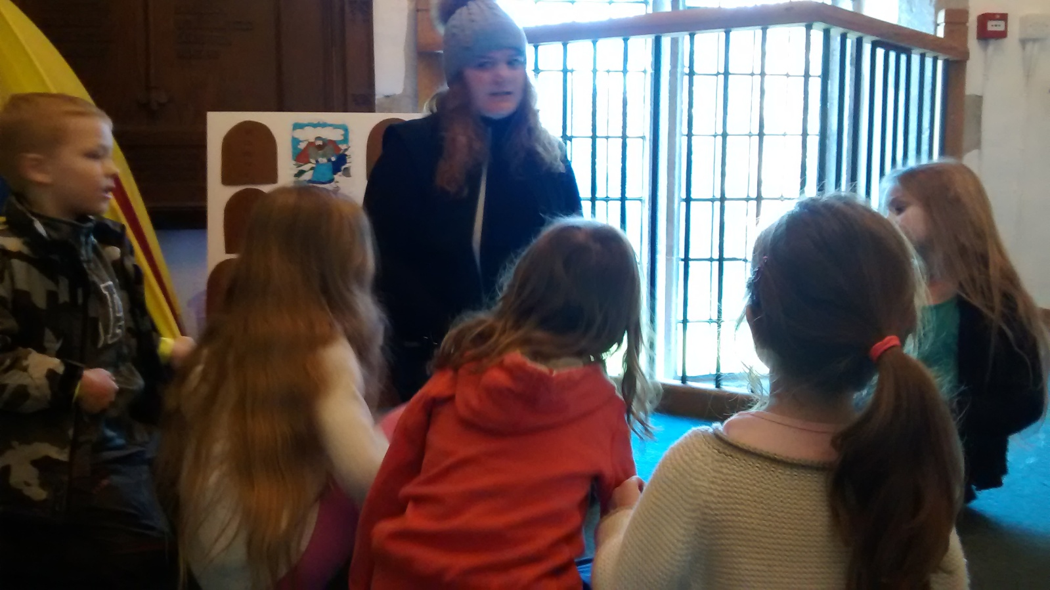
Fleur tells us the story of Moses
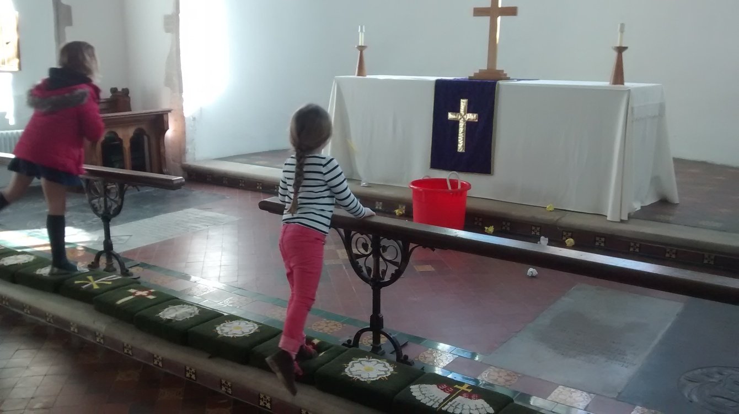
Competition time - can you throw the ball into the bucket?

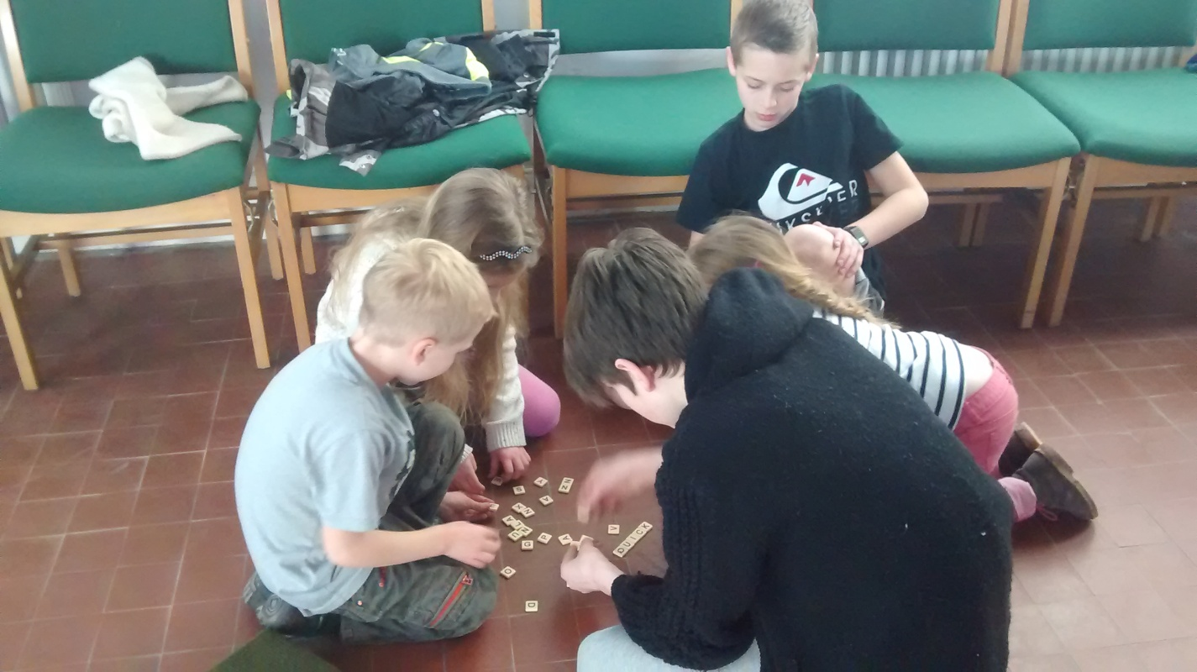
How many words can we make about mountains?
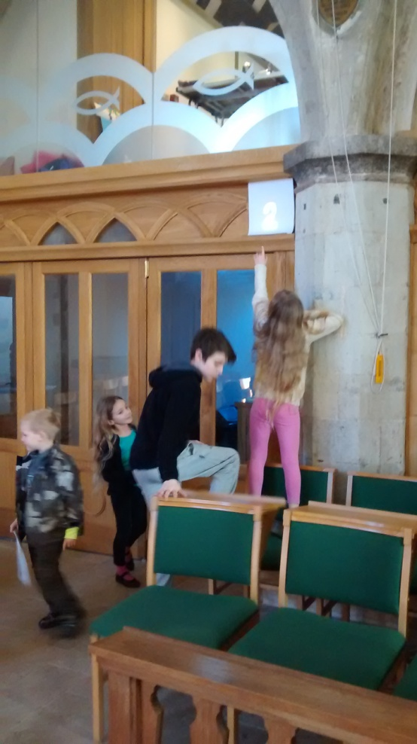
Can we find all of the 10 commandments?

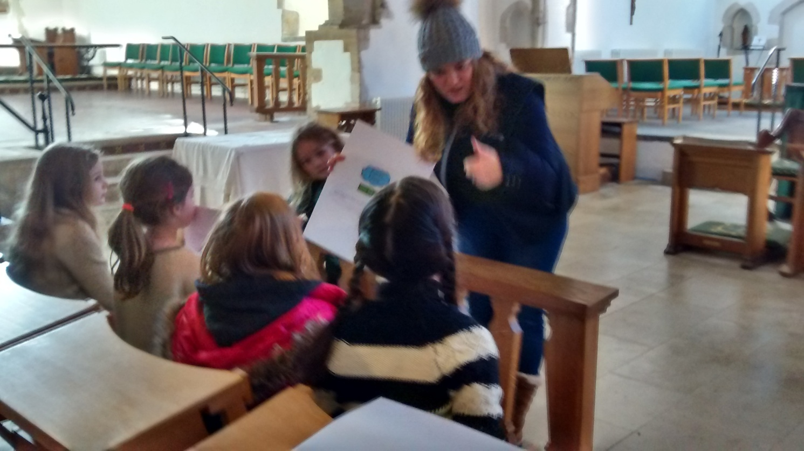
Now...what do they all mean?
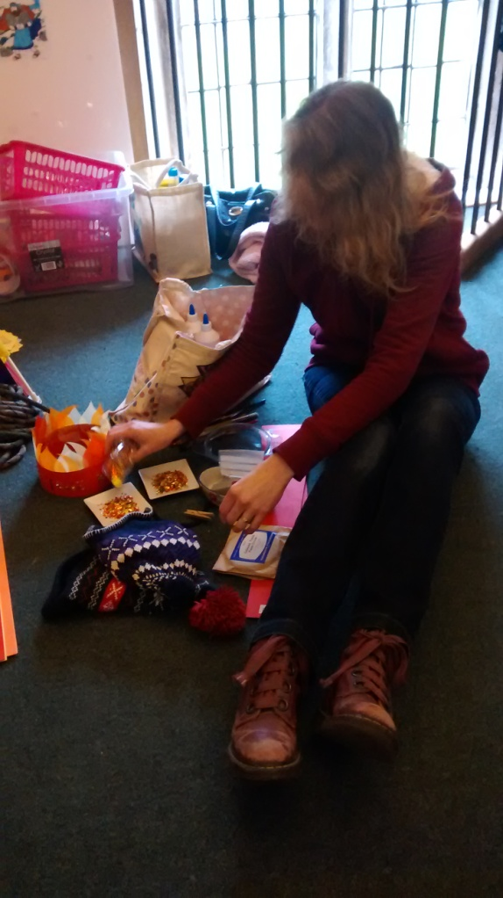
Helen gets the craft ready – are those sequins really a good idea?

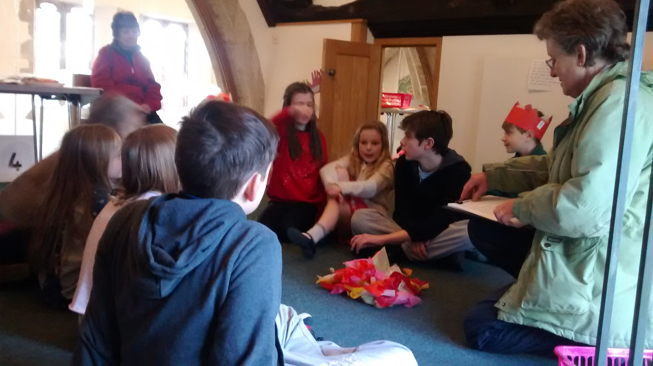
Joanna tells the story of Elijah and the priests of Baal – in all its gory detail!
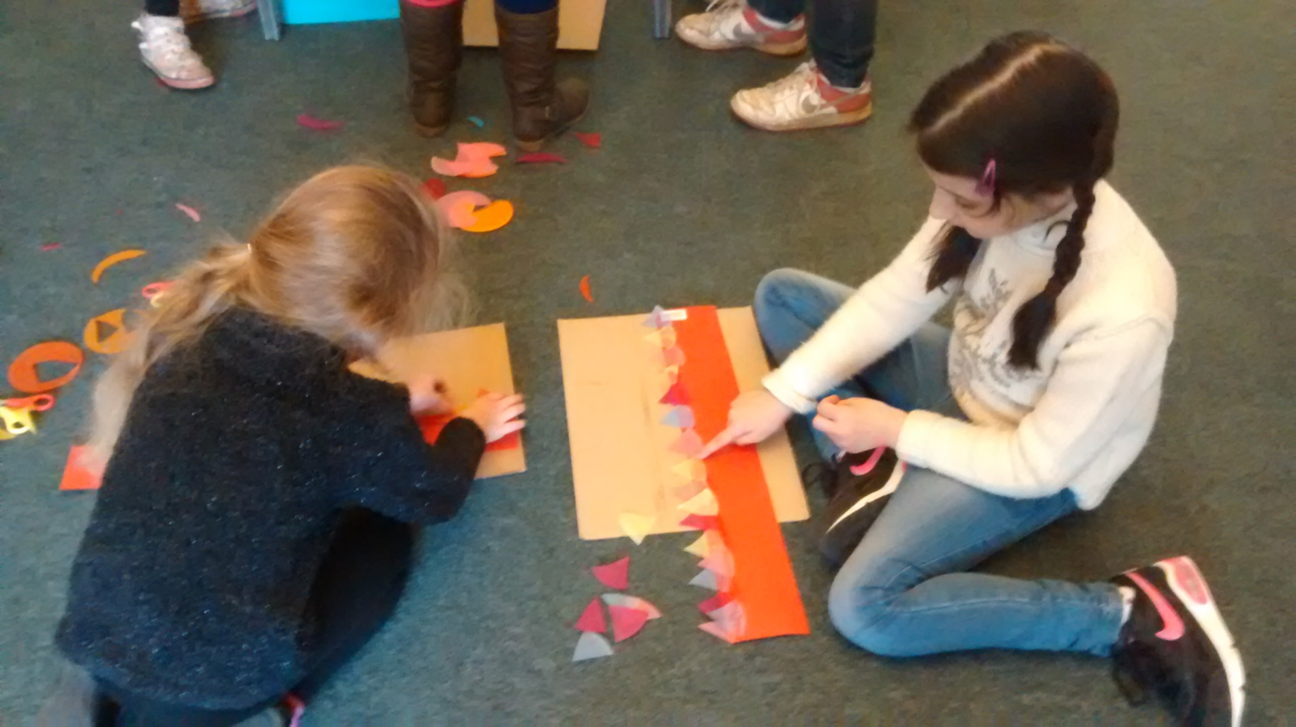
Making flames of fire hats

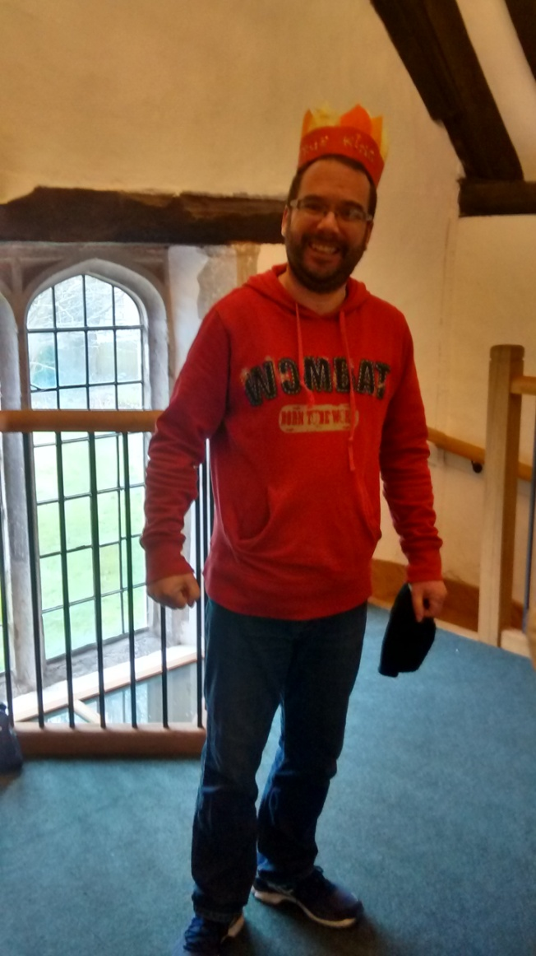
That’s what they look like!

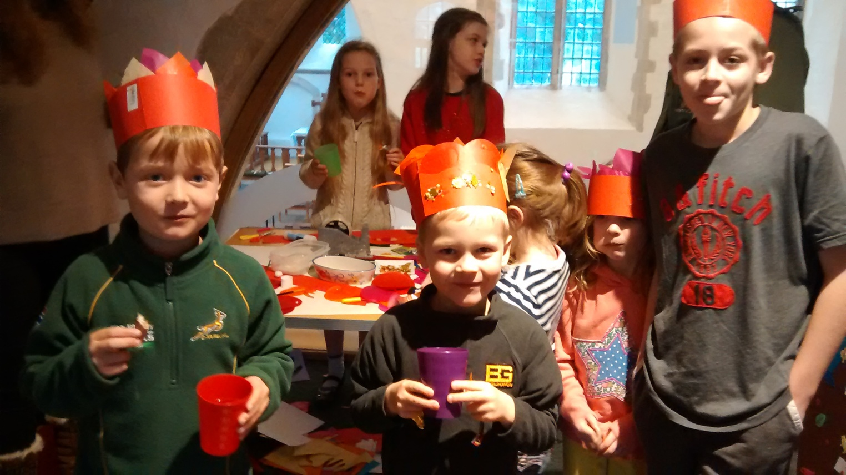
Its snack time

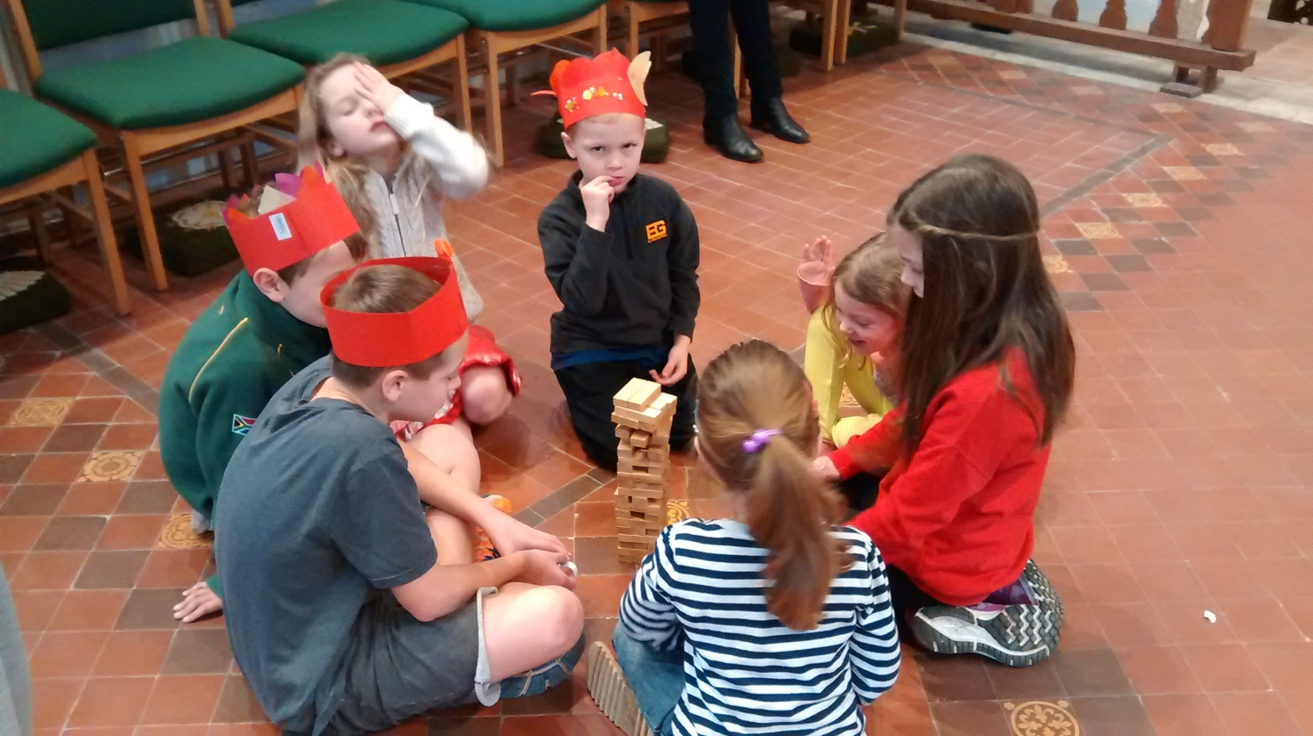
Who’s going to make the mountain fall?
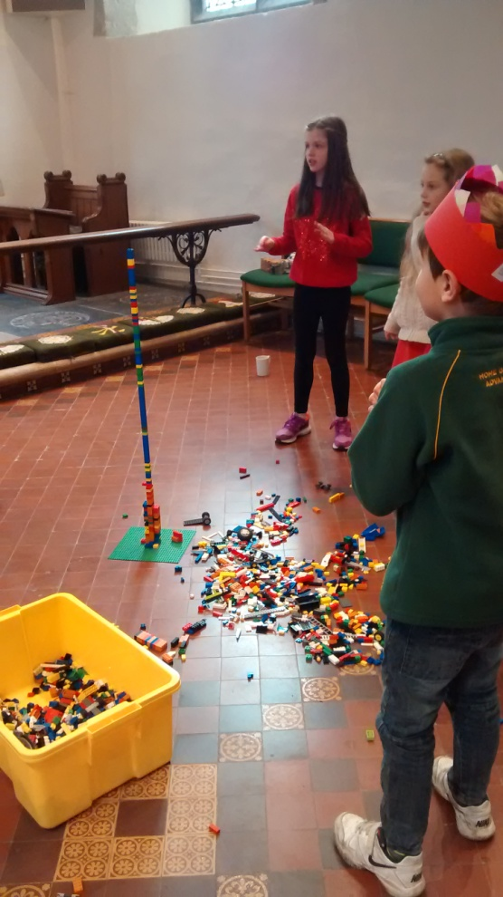
Which teams lego mountain is going to be tallest?

Quiz time – how many priests of Baal were there?
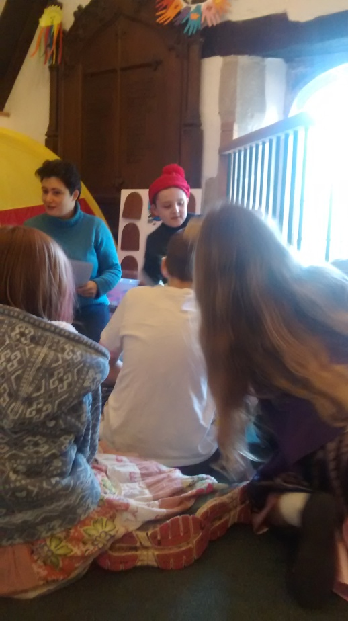
The story of the crucifixion and resurrection, with great acting by William

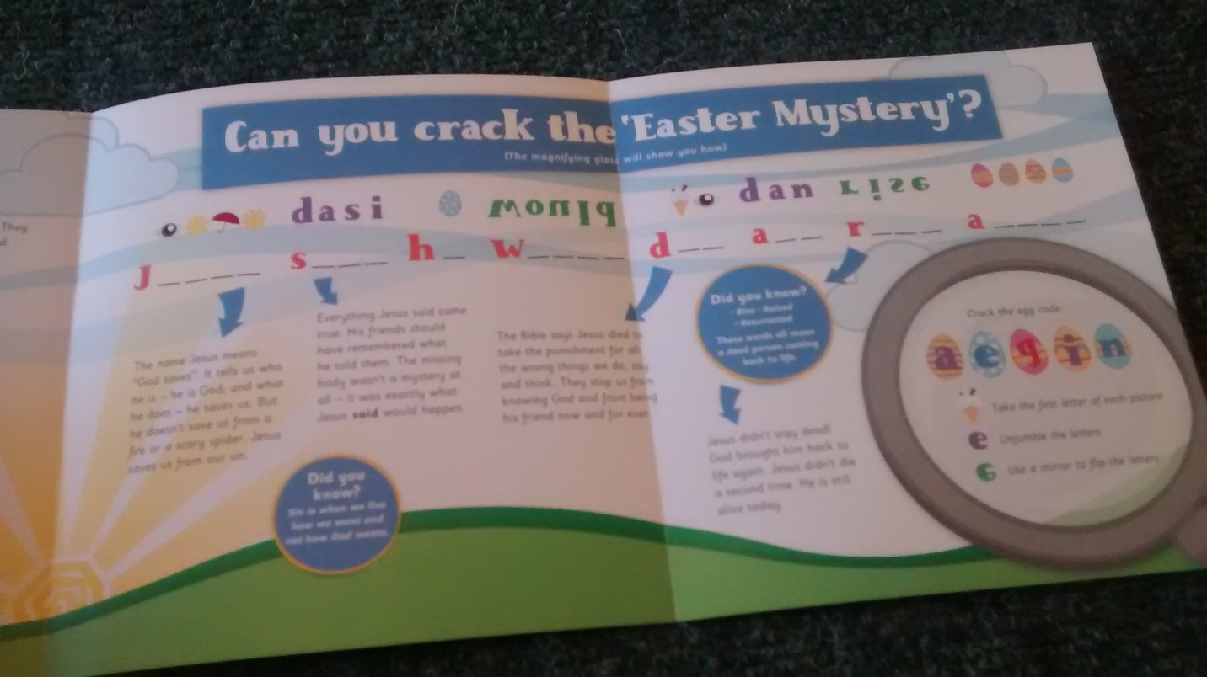
Figuring out what Jesus’ death and resurrection means for us
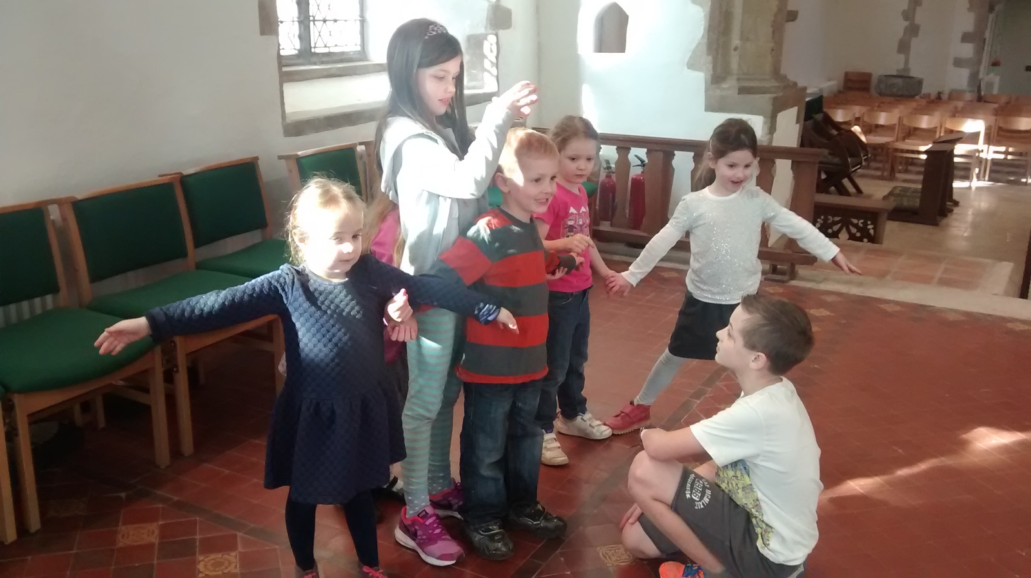
Making shapes out of bodies – this one is an angel!
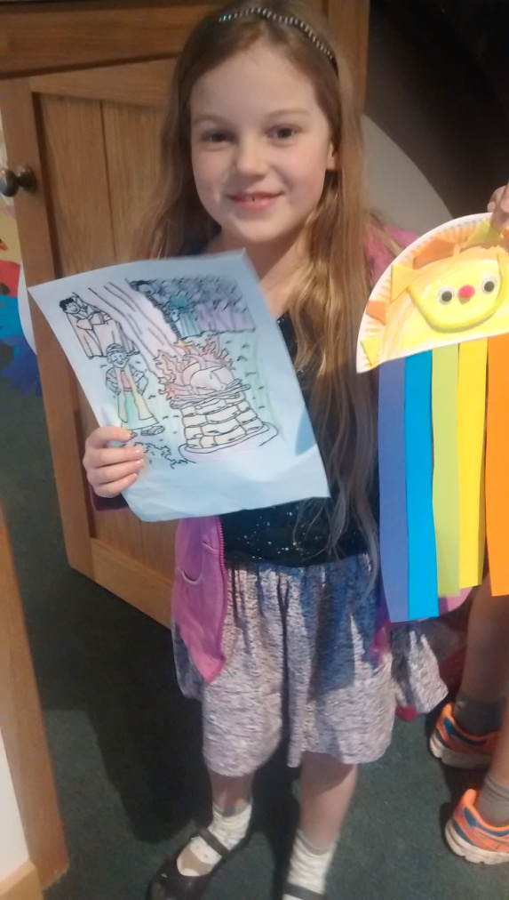
So much stuff to take home at the end of the week!

